New Tuesdays Health Walks Programme Begins:

1st and 3rd Tuesday of the month - 13.30 - 14.30 Meet opposite Tick Tock Cafe (was called Little Pickle) St Crispin retail outlet Kent Road NN5 4XB

2nd and 4th Tuesday of the month - 13.30 - 14.30 Meet in cafe at Duston Sports Centre (Trilogy) Cotswold Avenue Duston NN5 6EX

Please arrive in good time as we leave promptly at 13.30.
All Welcome
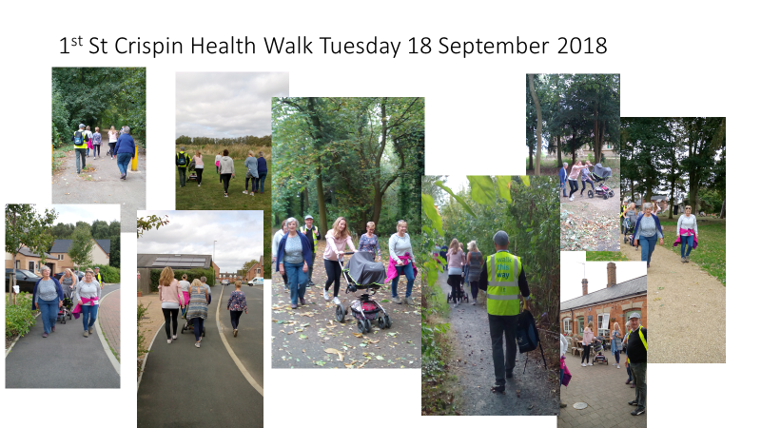

All walks are led by qualified walk leaders to help encourage and ensure no one is left behind.

They are short and over easy terrain with a number of options.
Walks are open to everyone but are especially aimed at those who are least active.

Visit https://www.walkingforhealth.org.uk/ for more info and to register.

The PPG at St Luke’s Primary Care Centre support this activity. Have a look at the PPG page on the surgery website https://stlukesprimarycarecentre.co.uk/

