MORE BOOKABLE GP

APPOINTMENTS AVAILABLE IN

NORTHAMPTON

6.30pm -9:30pm Weekdays, 9:00am-5:00pm Weekends

There are now more bookable GP appointments in Northampton, making it easier for you to get an appointment at a time that suits you including evenings, weekends and bank holidays

The Northampton GP Extended Access Service is an extension of your usual GP Practice, it is not a Walk-In-Service – You need to make an appointment.

The service is located on the ground floor of Highfield Clinical Care Centre, Cliftonville Rd, Northampton NN1 5BD
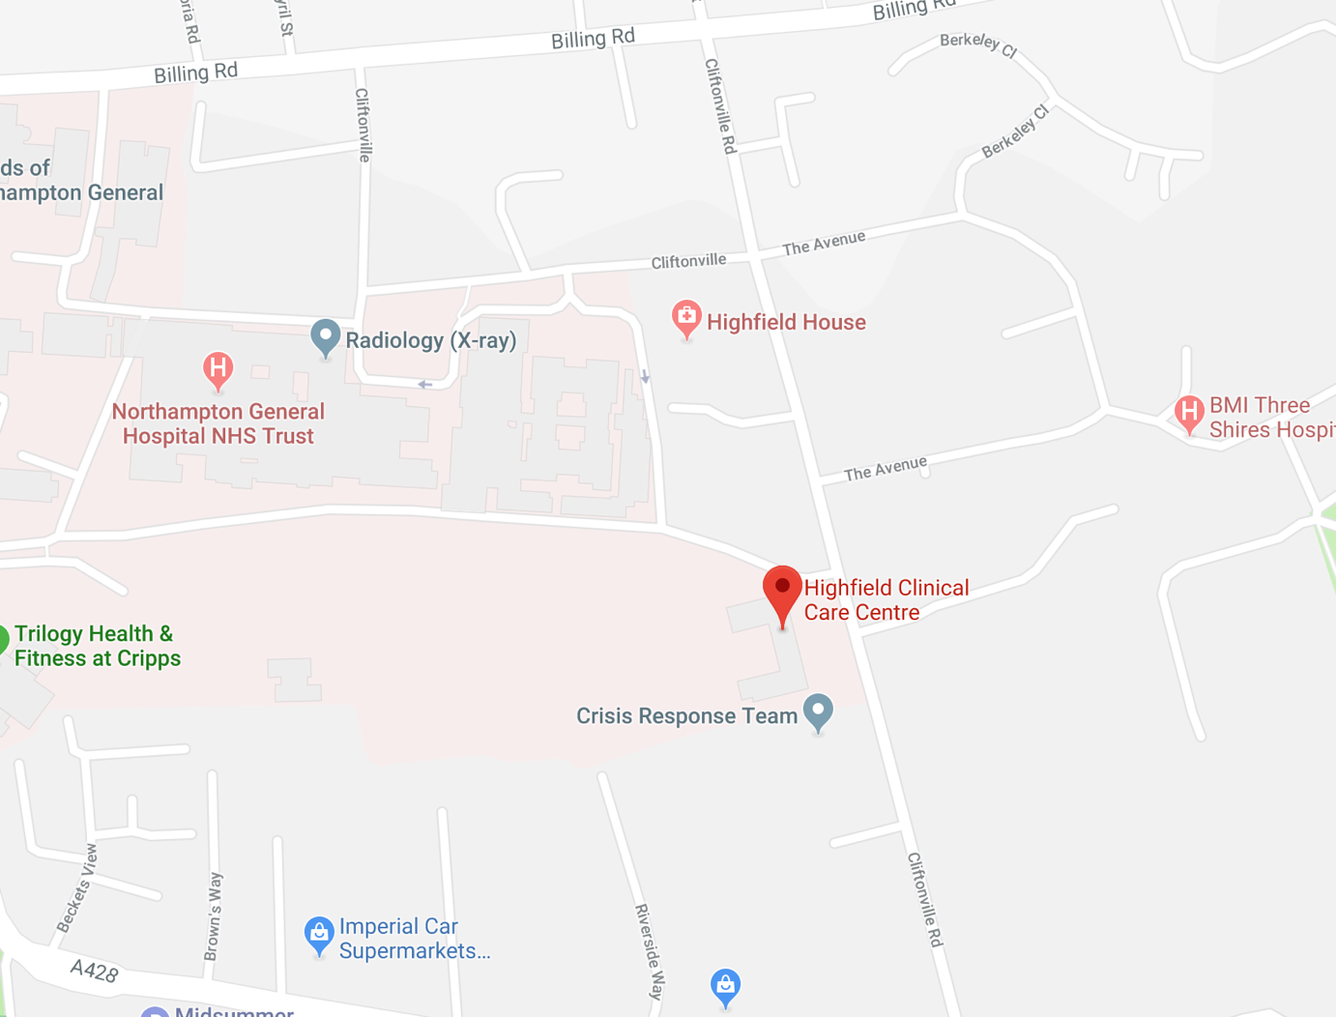

Getting here:

by Bus:

Several buses stop at the hospital and at the Cliftonville entrance which is closest to Highfield, buses include:

Buses traveling east: 1,5,55 & VH services.

Buses traveling west: 1,5,9B,51 & VH services.

by Car:

There are a limited number of free parking spaces available at the front of the building. Additional chargeable parking is available in the hospital grounds.

by Bike:

There are a number of covered cycle racks at the hospital and located at the front of Highfield.

Who can access appointments?

Anyone registered with a GP Practice in Northampton

How do I book an appointment?

Contact your GP Practice in the usual way to request an appointment. If there is no appointment available for you at the practice they may offer you an appointment with the GP Extended Access Service, if this is right for you.

If your practice is closed and you need a GP please contact the Out-of-Hours service through NHS 111. They will also be able to book an appointment for you with the GP Extended Access Service. Please note that your consent will be required in order for an appointment to be booked for you.

If urgent care is required, please call ‘111’ for further advice. If your need is life threatening, please go to A&E or call 999.

For support with the management of minor ailments, please contact your local pharmacist or visit the NHS Choice website www.nhs.uk or call 111 – www.111.nhs.uk

Will I see my own GP and/or Nurse?

You will be seen by experienced Northampton GPs and Nurses, but it is unlikely that you will be seen by your own GP or Nurse. If you would prefer to see your usual GP or Nurse, please book an appointment with your usual GP practice during their normal opening hours.

Will the GP I see have access to my medical record during my appointment?

Your medical record will, with your consent, be available to the Health Care Professional that sees you to ensure that they have the information they need to give you the best possible care.

A summary of your appointment will be sent back to your own GP practice electronically to ensure that your record is up-to-date. An appointment with this service will be just like an appointment at your own GP practice. Further information about how we use your medical record is available at www.northantsgpalliance.com/GDPR

How do I cancel an appointment?

If you need to cancel the appointment, please contact your registered GP Practice. A dedicated telephone number for cancellations will be shared soon.

When are these appointments available?

Appointments are available from 6:30pm – 9:30pm Weekdays, 9:00am -5:00pm Weekends.

Appointments need to be booked in advance.

Where do I go for my appointment?

The service is located on the ground floor of the main entrance of Highfield Clinical Care Centre, Cliftonville Rd, Northampton NN1 5BD.

To find out more about General Practice Alliance please visit www.northantsgpalliance.com/services-we-offer/gpea

