Northamptonshire Carers

E-Newsletter

Welcome to our regular e-newsletter

London Marathon 2021
Countdown has begun
Just under 5 months to go, Sunday 3rd October 2021
We have 3 charity places to run the Marathon 'Virtually' this year and looking for people to support us.

As with many Registered Charities we have not been able to fundraise in the usual way over the past year so really hoping some of you will get behind us for this.

You can walk, run, cycle, by yourself with friends and relatives, in a relay around your local park, you choose how you do the 26.2 miles being the distance of the Marathon in London.

We would set you up the fundraising platform and help and support you in anyway we can.
For further details, please contact the office on Tel: 01933 677907 or E:Mail

Helping the NHS
We continue to support the Vaccination Centre at Moulton Park with members of our staff and volunteers.

They are doing a fantastic job and we thank them all for their hard work and efforts as the Centre celebrated giving its 100,000th vaccination over the Bank Holiday Weekend

We need your help!

We are looking at how Northamptonshire Carers services and support can be more inclusive of different groups in society.

We are starting with Lesbian, Gay, Bisexual, Trans, Queer/Questioning, and anyone else on the gender and sexuality spectrums.

If any registered Carers could spare some time to come along and join in the discussion, we would really appreciate it.
Please contact Gaynor Roberts (pronouns – she/her) Quality and Impacts Manager on Tel: 01933 677907 or E:Mail

Heath Checks for People with Learning Disabilities

Did you know that anyone aged 14 or over who is on their GP's learning disability register can have a free annual health check once a year? If you or someone you care for has a learning disability,

Northamptonshire Carers and Voluntary Impact Northamptonshire will be running free online information sessions. Please E:mail or call 01933 677907 for more information and to sign up.
Visit our website for more information

National Carers Week
'Making Caring Visible & Valued'

7th - 12th June 2021

Our national week is very much in the planning stages, details to follow soon.

Find a Group or Activity

We want to remind you that many of the Support Groups, Cafe's, Choir, Parent Carer Groups, Dementia activities and more are still going ahead on Zoom.

You can find out how to join these and others from the office on 01933 677907, option 1 or there is an email address to a member of staff on the group details which are listed on our on Website

Carers Support Line Opening hours:

Mornings 9am - 12 noon
Afternoons 1pm - 4pm
Monday - Friday.

An answer phone is in operation outside of these times, please leave a message with your number and we will return your call.
We are there for information and advice as well as just someone to talk to for emotional support and a listening ear.

You are not alone - call us on 01933 677907, Option 2

Social Media
We have seen an increase of enquiries via Social Media which need an individual reply.
Can we just remind Carers that although Social Media is an easy and efficient way for us to get information out to Carers and other people in the community, we use a third party platform to post and our actual sites are not visited/monitored on a regular basis and certainly not 24 hours.

Two caring situations are not the same and the information we give out is tailored to the area where you live and your own caring situation. So, can we ask that if you have an enquiry that you make contact with the office in the usual way by phone, 01933 677907.
Thank you in advance for your understanding.

Are you looking for an employment opportunity?

We are currently looking to recruit two new members to our Team here at Northamptonshire Carers.

We are looking for a Group Worker and a Young Carers Wellbeing Group Worker, if you or someone you know is interested, go to our WEBSITE for details.

Please note we do not accept CV's, it must be an application form - Closing date for applications is Monday 10th May 2021 with interviews w/c 17th May 2021

Northampton Community Sheds update
Northampton Community Shed is an organisation that can offer all members of the community the opportunity to meet up in a social setting helping to prevent social isolation giving friendship and companionship.

The workshop facilities gives the opportunity for people to swap skills and learn new skills in a safe environment.
Northampton Community Sheds are working with The Big Lottery and other Partners to seek funding to expand into new premises in order to increase their membership.
This will give them the opportunity to offer new facilities for metal work, pottery and other skills.
If you would like to know more about their organisation or might be interested in helping them with their expansion plans, please make contact with the Chair of the Trustees:
Phil Osborne on Tel: 07515 932884 or E:mail

WE ARE STILL LOOKING FOR MORE VOLUNTEERS TO JOIN OUR TELEPHONE BEFRIENDING SERVICE
Do you have an hour or so spare every week - Are you a good listener, friendly and enjoy chatting to people on the phone?

Northamptonshire Carers support unpaid Carers throughout Northamptonshire. The Coronavirus Pandemic has changed lives for everyone and many Carers are amongst those hardest hit. We are looking for volunteers to help us extend our Telephone Befriending Service to Carers who would really benefit from having someone to talk to on a regular basis.

You will be provided with lots of support and training – please contact Linda Tiffney for a very informal chat on 01933 677907 or email

Walking for Mental Health and Mindfulness
We continue to review what activities we can safely organise, with that in mind starting on the 28th May we will be teaming up with Northamptonshire Sport and taking part in some health walks around Irchester Country Park.
This regular meeting will be held twice monthly on the 2nd and 4th Friday until October between 10.30am and 12.30pm

All abilities welcome, please just turn up or contact the office for more details on 01933 677907, option 1 or EMail

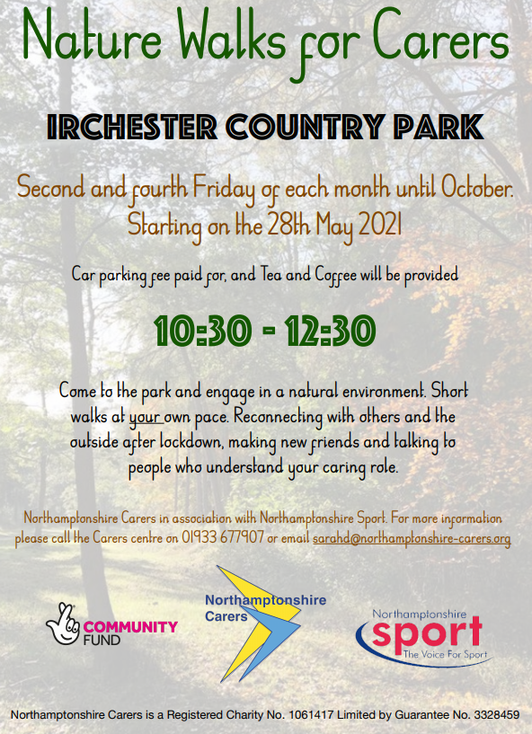

Northamptonshire Carers supported Media Blackout

Throughout the coronavirus pandemic, we have seen that social media can be a positive tool to connect carers and young carers to friends, families and services. Unfortunately, online racial abuse is far too common and as such Northamptonshire Carers joined the social media boycott from 3pm on Friday 30 April to 23:59pm on Monday 3 May 2021.
We decided not to post or schedule content across our social media channels over this bank holiday weekend. Northamptonshire Carers fully support the boycott of social media originating in the football community and wanted to show of solidarity against online abuse.
Providing care for a loved-one has always been universal: one-in-ten of the population are carers, regardless of race, religion and cultural background. We feel that the online space should be safe for all carers, free from racism and discrimination.

Useful resources:
Equality Advisory and Support Service (EASS) advises and assists individuals on issues relating to equality and human rights. Phone: 0808 800 0082
The Monitoring Group provides support to victims of race and religious hate crime through the provision of information, advice, advocacy, and representation.
Stop Hate UK provides independent and confidential support to people affected by hate crime, including confidential hate crime reporting services.

Community Lotteries
We are registered with 3 of the local Community Lotteries, these Lotteries ensure that local money supports the local communities.
You don't need to live in the area to play so if you play the Lottery, we ask if you would consider supporting our organisation?

Corby - Click here
Daventry - click here
Northampton - click here

If you do gamble, we ask that you do so responsibly

Contact us Monday - Friday 9am - 5pm
Office & Carers Support Line: 01933 677907
Email: carers@northamptonshire-carers.org
Website: www.northamptonshire-carers.org
Fundraising donations: www.localgiving.com/northampotnshire-carers

Facebook | Twitter | YouTube

