Dr Astbury & Partners

2012/13

Patient Satisfaction Survey
Report

Contents
PRACTICE MANAGER’S INTRODUCTION 2
THE QUESTIONS 5
EXPERIENCE 5
Reception & Telephones 5
Appointments 7
Clinicians 9
Opening Times 11
Care & Treatment 12
Premises 16
Overall Experience 17
DEMOGRAPHICS 19
Development Action Plan 24
Notes 26

PRACTICE MANAGER’S INTRODUCTION

We received a total of 526 completed questionnaires. Not all questions were answered by all respondents. For each question we have provided a table with detailed responses and the Grand Total of responses to that question. Where percentages are given, these relate to the Grand Total of responses to the related question and not to the 526 received questionnaires.
The Patient Satisfaction Survey took place during January and February 2013. All of the
Patient Participation Group and Patient Reference Group were offered the opportunity to complete the survey either by hard copy or email. Additionally the practice requested randomly, c50 patients for each full time doctor to complete the survey.

In view of the new ‘Dr First’ appointment system which reduces the number of patients who are seen by doctors face to face, it was more difficult to get surveys completed. However we are very pleased to be able to report that 526 were completed compared with 544 in 2012. The practice would like to thank all those patients for taking part. The survey has proved extremely useful in helping the practice to put together the Development Action Plan which appears in appendix 1 of this document.

Just under two thirds of the patients completing the survey were female and there was an excellent mix of age groups. This was very similar to those taking part in the questionnaire for 2012

The areas the survey covered and the questions in the survey were developed and agreed with the Patient Participation Group who have also helped to produce the Development Action Plan.

An overview of the various areas appears below and the body of the report contains an analysis of the results of each question asked.

It is worth mentioning that the questionnaire commenced less than two months after the practice had closed the two sites at the Harlestone Road Surgery and the Duston Medical Centre and transferred all the patients to the purpose built St Luke’s Primary Care Centre.

It is fair to say that systems at the new centre were still bedding down during the course of the questionnaire period and indeed still are.

Immediately prior to the move to St Luke’s the practice had taken part in a pilot sponsored by the Northamptonshire Primary Care Trust, to implement a revolutionary new appointments system where all patient requests for an appointment are telephoned triaged by a doctor before the appointment is booked by the doctor where appropriate.

This has resulted in a significant change in the role of the doctors, nurses and receptionists.

The new appointments system enables the practice to provide much improved access to the doctors. The vast majority of patients are seen by the appropriate clinician on the same day. The system is still being improved and the comments made in the questionnaire will be reviewed as a part of the development of the Action Plan at the end of this document.

Reception (26 comments)
98% (99% 2012) of patients found the receptionists to be either very helpful or fairly helpful which is very encouraging. Over half of the comments relating to the receptionists found them to be helpful and friendly.

Some patients found receptionists to be unhelpful and queues unacceptably long. The practice will be reviewing these comments and this will form part of our action plan.

Some of the comments made:

‘Didn't need to see Receptionist but they were very helpful when booking’.
‘Whole experience is a contrast to previous visit to Harlestone Rd. surgery - polite receptionists, prompt action, ease of booking appointments. Nice building with friendly characters, definitely good investment. Improved booking system most positive step’.
‘The system works but it took me too long to get through this morning. Need more receptionists please,’
‘Queue at Reception, always waiting too long’

Telephones (19 comments)
69% (65% 2012) of patients felt that it was very easy or easy to get through on the telephones. Whilst an improvement on last year this remains unacceptably low. We have a new system with a dedicated telephone team but further work needs to be done to improve the service we provide.

Some of the comments made:

‘Getting through on phone varies according to the time of day’
‘Thanks for getting the phone lines sorted.’
‘Too long waiting for the telephone to be answered’
‘Only problem is getting through to make an appointment on the phone’

Appointments (43 comments)
89% (85% 2012) of patients found the current system to be very convenient or convenient. 77% (80% 2012) thought that 48 hour appointments were either very important or important. Having recently implemented the new Dr First appointments system there was unsurprisingly a wide range of comments relating to this subject some very positive and some who felt that the system did not work for them. 58% of the comments were very positive about the new system with 42% having some concerns. Many of the concerns are due to the practice not explaining how the new system operates and this area will form a part of our Action Plan.

Some of the comments made:

‘The new system in my opinion is a significant improvement on the old’
‘Could not have been seen any quicker, didn't have time to think about it. Very good’
‘No objection to initial phone consultation but difficult to take calls at work, no mobile signal and not private. I have to arrange to be at home but then may not need appointment anyway’
‘Prefer the old appointment system’

Doctors – How quickly does the patients get seen (80 comments)
65% (27% 2012) of patients usually get seen within 1 – 5 days. Whilst this is an excellent improvement, it is not consistent with the actuality of what happens when in fact the vast majority of patients needing to be seen will be seen on the same day.

Some of the comments made:

‘I am very happy with my doctor. In fact, he is the best doctor I have ever had, very thorough helpful and caring’
‘Great doctor, always great to us. Thanks’
‘I have excellent service from doctors and nurses’
How do you rate this?
88% (59% 2012) felt this was excellent, very good or good. 9% felt the system for seeing their doctor was satisfactory, only 3% (38% 2012) felt the system was not ok. Whilst there were a number of concerns (see above) this serves to demonstrate that whilst not perfect how effective the new appointments system is.

Opening Times (1 comment)
91% (91% 2012) of patients thought that the opening times were either excellent, very good or good. One patient suggested a drop in Centre but was reassured by the extended opening hours

Care and Treatment
98% thought the care and treatment was very good or good. 2% felt it was satisfactory

Premises (43 comments)
94% (74% 2012) of patients rated the premises as excellent, very good or good. Many patients felt the new premises were excellent e.g. ’Love the design and cleanliness of the new surgery – spacious, car parking spaces, location. The screen actually works and is easy to use.’ ‘Nice building with friendly characters, definitely a good investment, improved booking system definitely most positive step’

Never the less a significant number of patients felt we should have something for children to play with and we have included this as an area we will address in the Development Plan.

Overall how would you describe your experience of the surgery?
98% said excellent, very good or good. 2% said satisfactory

THE QUESTIONS

EXPERIENCE

Reception & Telephones
  - How helpful do you find the receptionists at the surgery?
Answer | Number
Very Helpful | 363
Fairly Helpful | 135
Unhelpful | 11
Not at all helpful | 2
Grand Total | 511
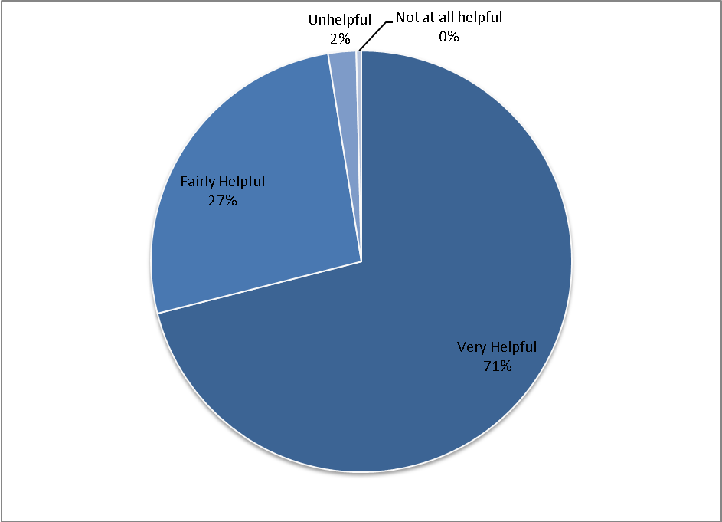

  - How easy is it to get through to someone at the surgery on the phone?
Answer | Number
Very Easy | 130
Easy | 223
Not very Easy | 154
Don't Know | 6
Grand Total | 513
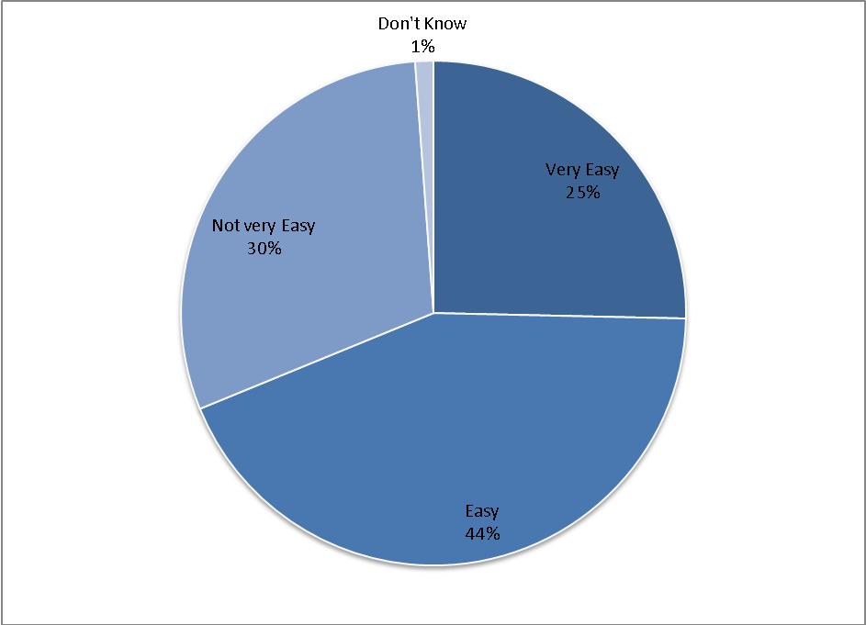

Appointments
  - The surgery offers an appointment system where you are offered a telephone consultation as the initial method of consulting with a doctor. This may mean that you do not have to come to the surgery for a face to face consultation, or if you do need to come, the doctor can see you at your convenience
  - How do you find this system?
Answer | Number
Very Convenient | 234
Convenient | 215
Inconvenient | 46
Very Inconvenient | 12
Grand Total | 507
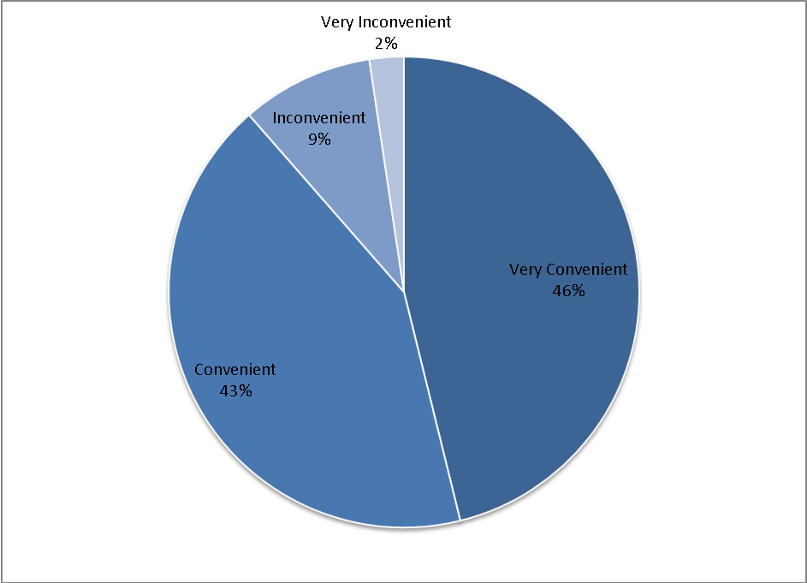

  - How important is it to you to be able to book appointments more than 48 hours in advance?
Answer | Number
Very Important | 203
Important | 193
Not that Important | 108
Not at all Important | 10
Grand Total | 514
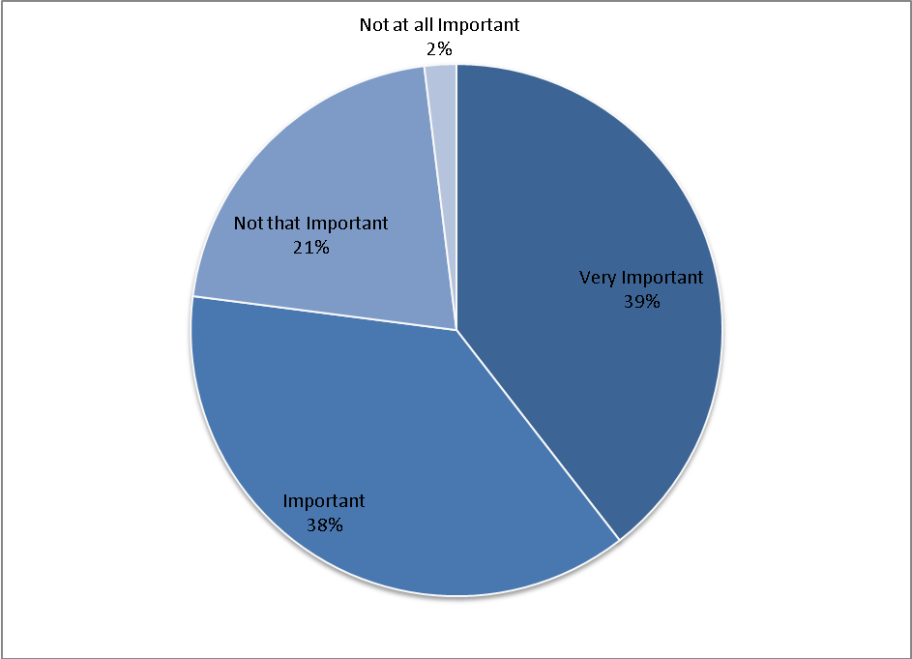

Clinicians
  - How quickly do you usually get seen?
Answer | Number
Same Day | 215
Within 1 Week | 115
I don't mind who I see | 91
Don't Know / Never Tried | 86
Grand Total | 507
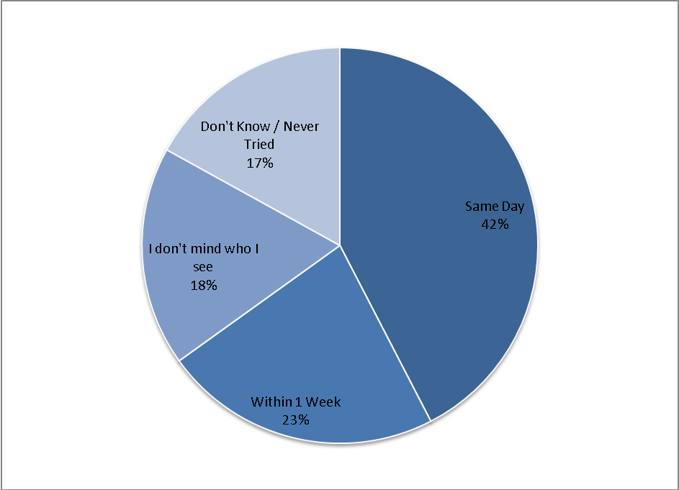

  - How do you rate this?
Answer | Number
Excellent | 204
Very Good | 137
Good | 78
Satisfactory | 43
Poor | 8
Very Poor | 3
Grand Total | 473
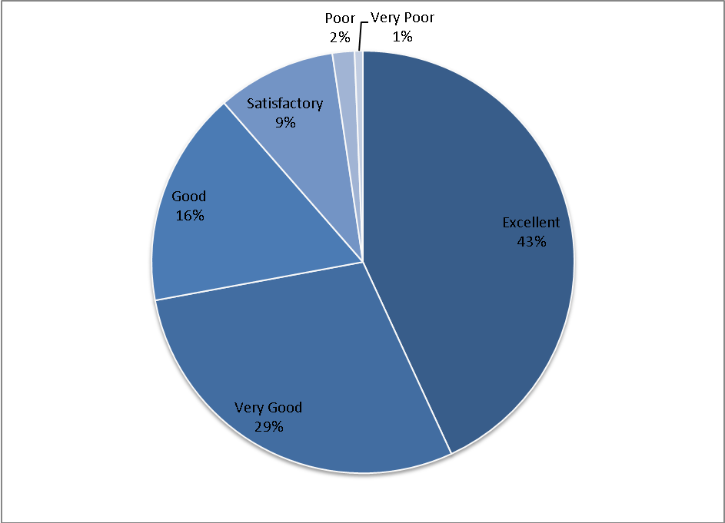

Opening Times
  - The surgery offers extended opening times from 7:00am and until 8:00pm. How do you rate these opening times?
Answer | Number
Very Good | 308
Good | 150
Satisfactory | 40
Poor | 4
Grand Total | 502
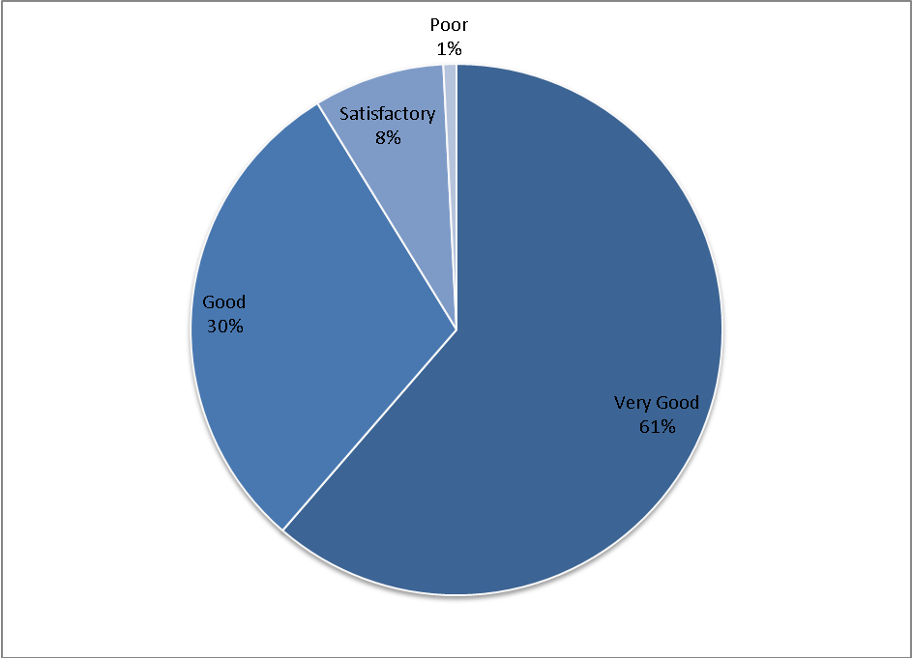

Care & Treatment
  - Thinking about your most recent consultation, how good was the doctor at:
  - Explaining your condition & treatment?
Answer | Number
Very Good | 416
Good | 75
Satisfactory | 12
Poor | 1
Grand Total | 504
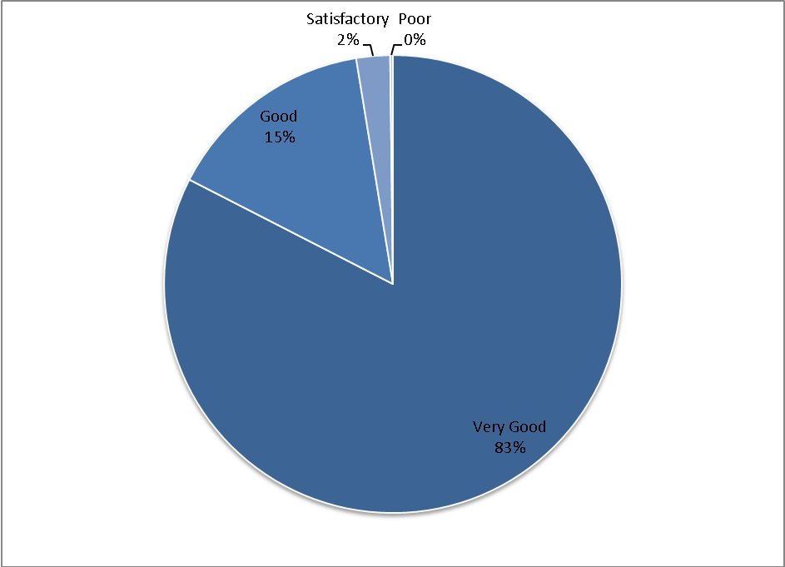

  - Involving you in decisions about your care?
Answer | Number
Very Good | 362
Good | 112
Satisfactory | 18
Poor | 1
Grand Total | 493
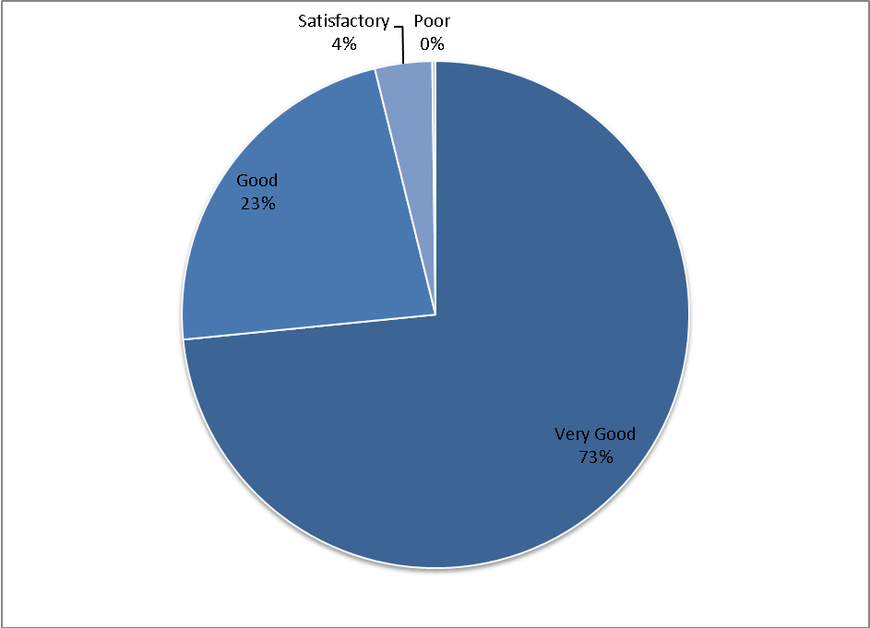

  - Providing or arranging treatment for you?
Answer | Number
Very Good | 368
Good | 108
Satisfactory | 17
Poor | 3
Grand Total | 496
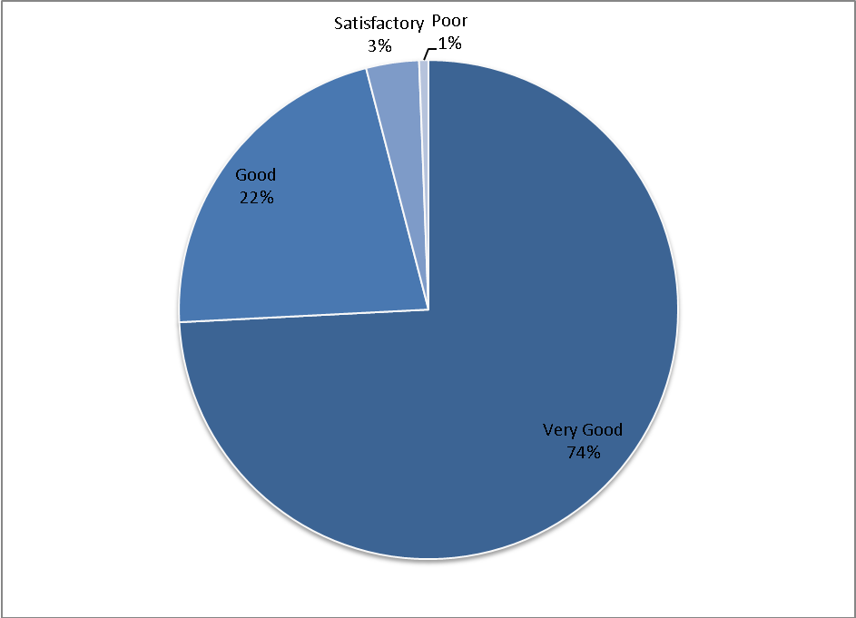

  - Providing information about your medication?
Answer | Number
Very Good | 332
Good | 126
Satisfactory | 23
Poor | 2
Grand Total | 483
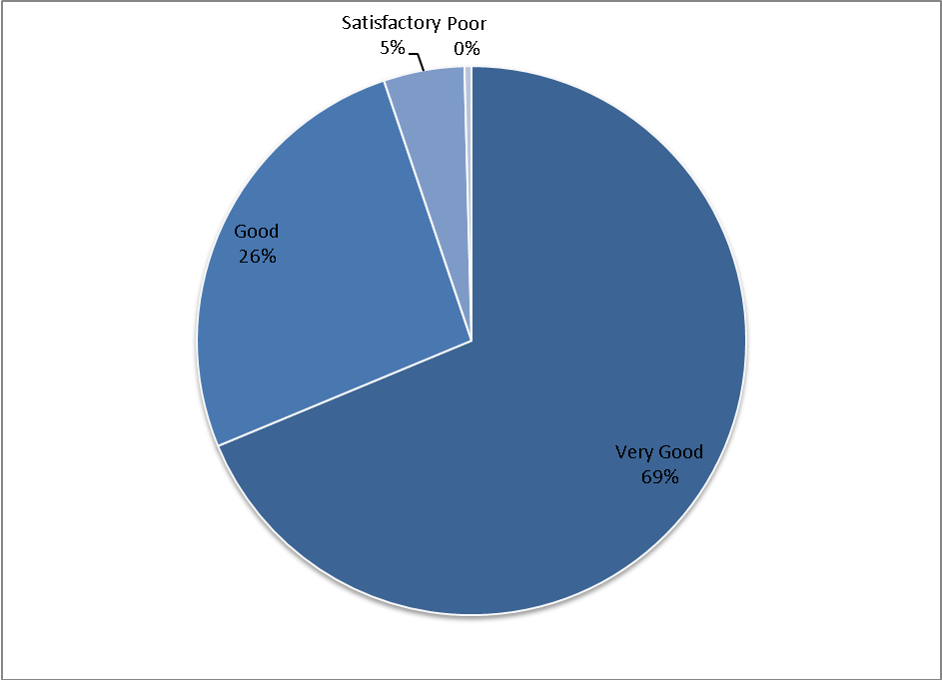

Premises
  - How do you rate the waiting area at the surgery, including music played, magazines, health promotion material and seating?
Answer | Number
Excellent | 263
Very Good | 144
Good | 64
Satisfactory | 21
Poor | 10
Very Poor | 2
Grand Total | 504
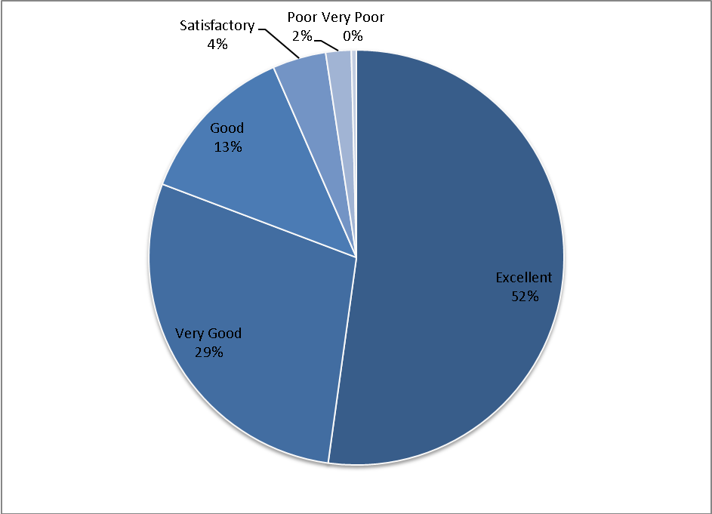

Overall Experience
  - Do you feel that you are treated with dignity and respect and that your privacy is respected by the staff and clinicians at the practice?
Answer | Number
Yes Always | 419
Most of the time | 85
Not very often | 1
Never | 0
Grand Total | 505
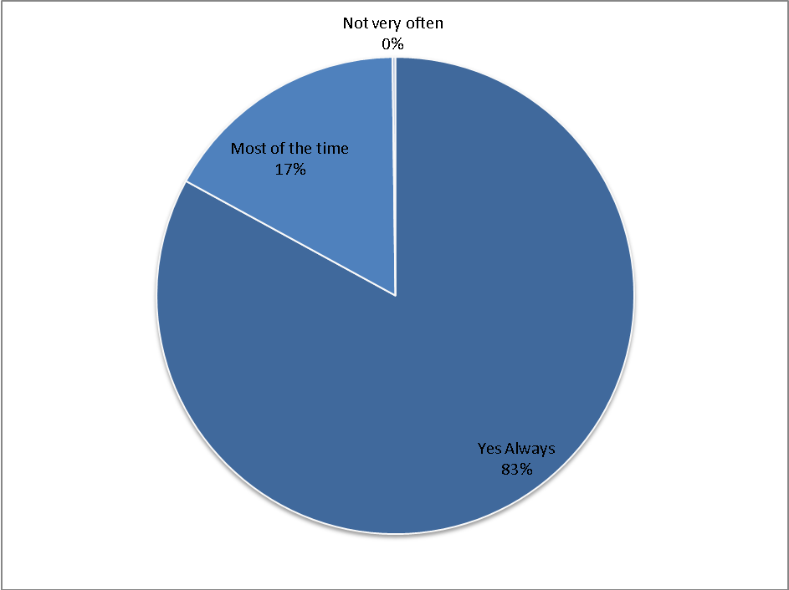

  - Overall, how would you describe your experience of the surgery?
Answer | Number
Excellent | 248
Very Good | 191
Good | 55
Satisfactory | 8
Poor | 2
Very Poor | 1
Grand Total | 505
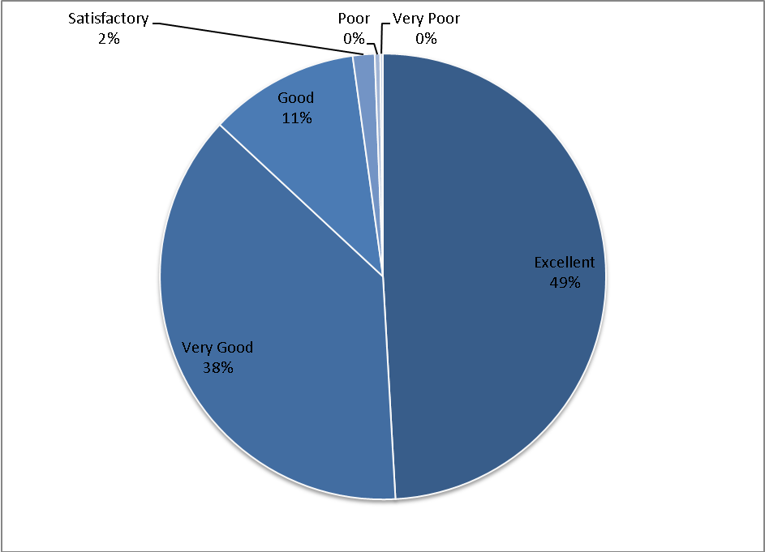

DEMOGRAPHICS
  - Gender
Answer | Number
Male | 181
Female | 322
Grand Total | 503
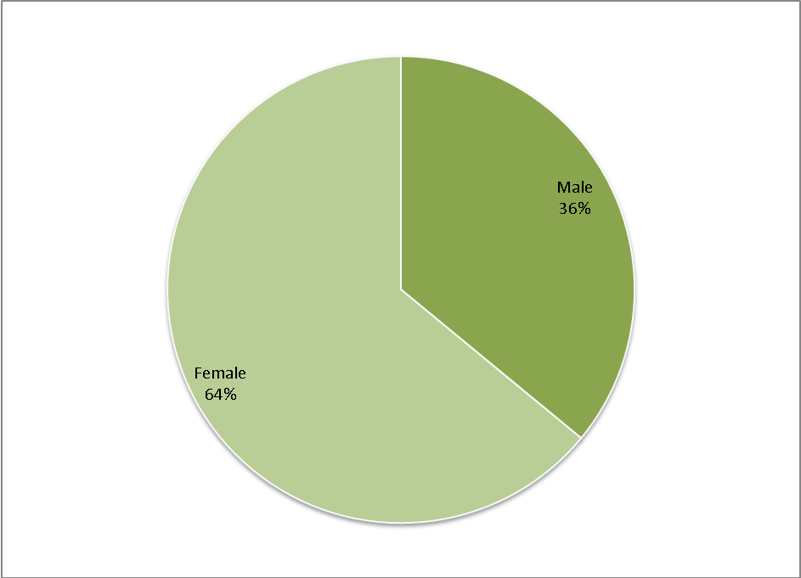

  - How old are you?
Answer | Number
16-29 | 100
30-44 | 163
45-64 | 119
65-74 | 81
75 or over | 40
Grand Total | 503
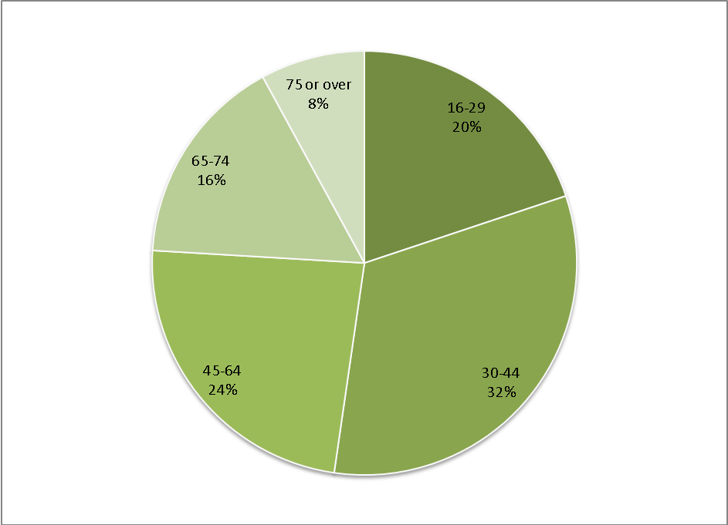

  - Have any longstanding health conditions?
Answer | Number
Yes | 201
No | 265
Don't Know / Don't want to answer | 33
Grand Total | 499
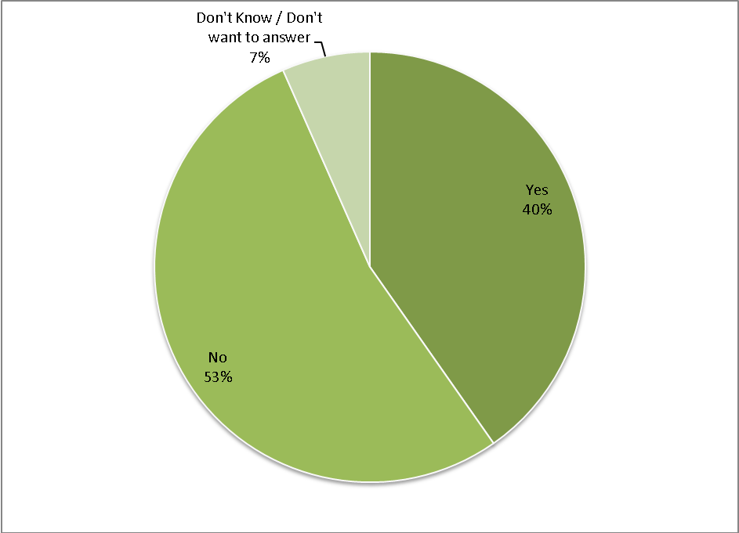

  - What is your ethnic group?
Answer | Number
White | 457
Black | 13
Asian | 16
Mixed | 10
Chinese | 3
Grand Total | 499
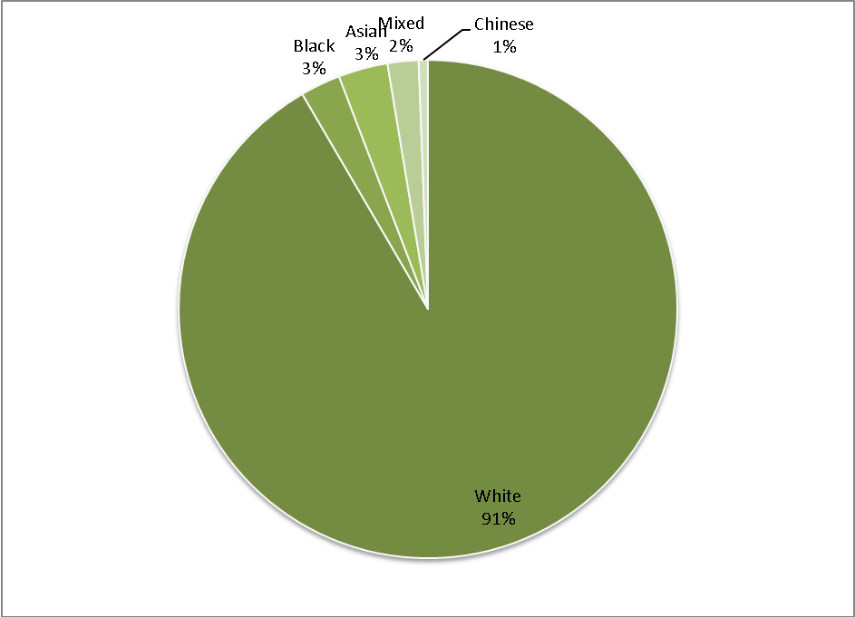

  - Which best describes you? (Employment Status)
Answer | Number
Employed (full or part time including self-employed) | 305
Unemployed / looking for work | 11
In full time education | 15
Unable to work due to long term sickness | 15
Looking after family /home | 39
Retired from paid work | 120
Other | 6
Grand Total | 511

Development Action Plan

Area | Action Required | Timescales | Success Criteria/ Measured By | Date Completed | Current Position/Comments | Lead
Reception | To work with the Reception Team to provide a more customer focused service | Qtr 4 2013 | Improved empathy and friendliness. Measured by new questionnaire Qtr 4 |  | 2/13 to provide a more ‘customer focused service’ will form part of the objectives for all reception appraisals’ | GJ
Telephones | Following the implementation of a new telephone system we now need to use data which has only just become available to identify the specific requirements of the new dedicated telephone team | Qtr 3/4 2013 | Patients can get through to the practice more quickly, less waiting time. Reduce/ avoid engaged signal. measured by new system and questionnaire Qtr 4 2013 |  |  | GJ
Appointments | Following implementation of the new Dr First Appointments system we need to continue to review and change to improve the service available to patients. | Qtr 3 2013 | Patients able to get the appointments they want more quickly. Measured by new questionnaire Qtr 4 2013 and reduction in adverse comments on NHS Choices website |  |  | GJ
Appointments | We also need to educate patients as to how the new system works | Qtr 3 2013 | As above |  |  | GJ
Doctor Availability | Whilst we have seen a dramatic improvement 59% 2012 to 88% 2013 we need to improve further on this | Qtr 3 2013 | Patients able to get the appointments they want more quickly. Measured by new questionnaire Qtr 4 2013 |  |  | GJ/MS
Premises | Need to have a Children’s toy area | Qtr 2 2013 | Measured by comments in Qtr 4 2013 questionnaire |  |  | GJ

--- = completed

Notes
- The analysis of the Patient Questionnaire and the above action plan have been discussed and agreed at a Practice Meeting (see attached minutes)
- It was further discussed with the Patient Participation Group, at a meeting on Monday 18th March 2013. (see minutes attached)
- High level details of the results of the Patient Questionnaire will appear in the Spring edition of the Patient Newsletter (to go out shortly) together with details of how to obtain a copy of the report
- There are notices in the waiting rooms advising patients that they may have a copy of the report on request

