Not all survey results tell the same story !
We are hugely deflated by the National Patient Survey results,
we want you to see the facts!

These are the results of the National Friends and Family Survey, during the same period January to April 2018

87% of our patients were either extremely likely or likely to recommend our practice to their friends or family.
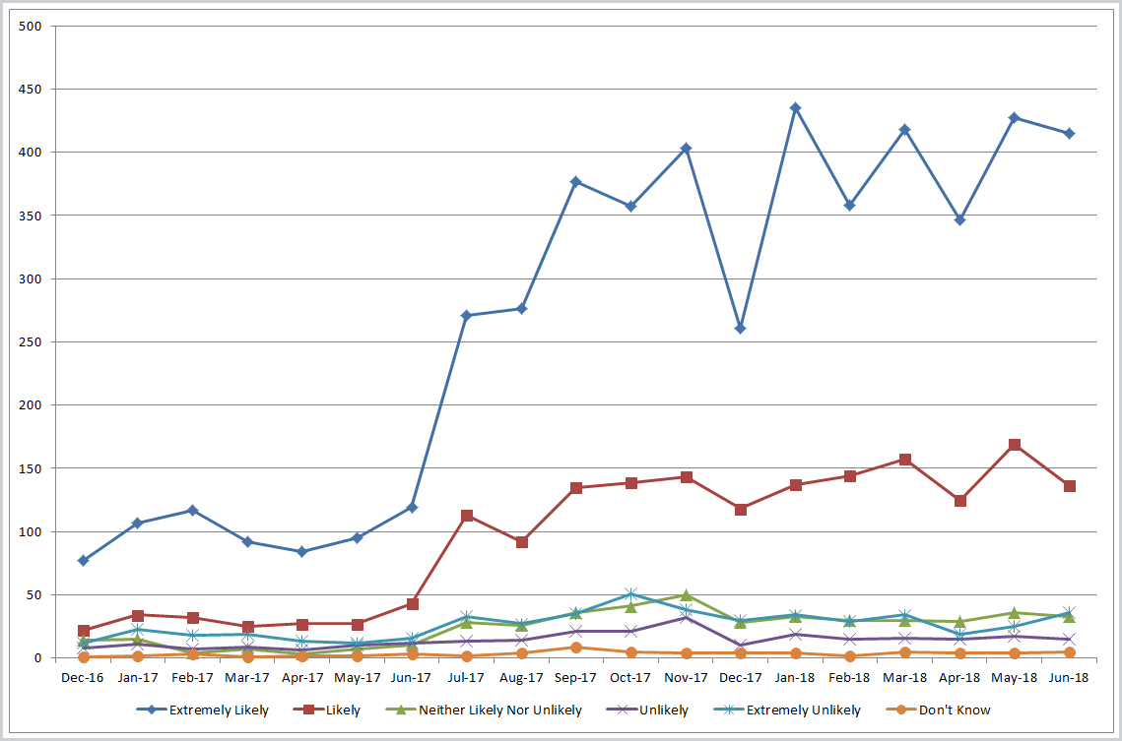

98% of patients felt they were treated by their clinician with care and concern
We offer over 200 emergency appointments every single day.
We always see a patient who clinically needs to be seen.
We offer over 2000 appointments a week.
We offer over 100,000 appointments
every year
Please do not judge our service
based upon only 111 responses,
that’s only 0.5% of our patient population!
Please remember statistics have to be interpreted cautiously.
We did our own patient survey, using the same questions as the National Patient Survey and we got vastly different responses.
It was honest and transparent, our Patient Participation Group helped ensure it was carried out correctly.
Two things jump out :
- For most of the questions, our patient satisfaction was over 90%,

- Particularly interestingly, when we talk about the risk of interpreting statistics, the final column shows a massive drop in apparent quality of service. When we looked into why, it was because the question was only to be asked if the patient expressed a preference of which GP they wished to see, and so the sample size reduced massively leading to the final column actually only representing the results from 5 patients.
We found 90% of our patients did not mind which GP they saw! The patient survey then only uses the number of patients that wish to see a specific GP to calculate the percentage.
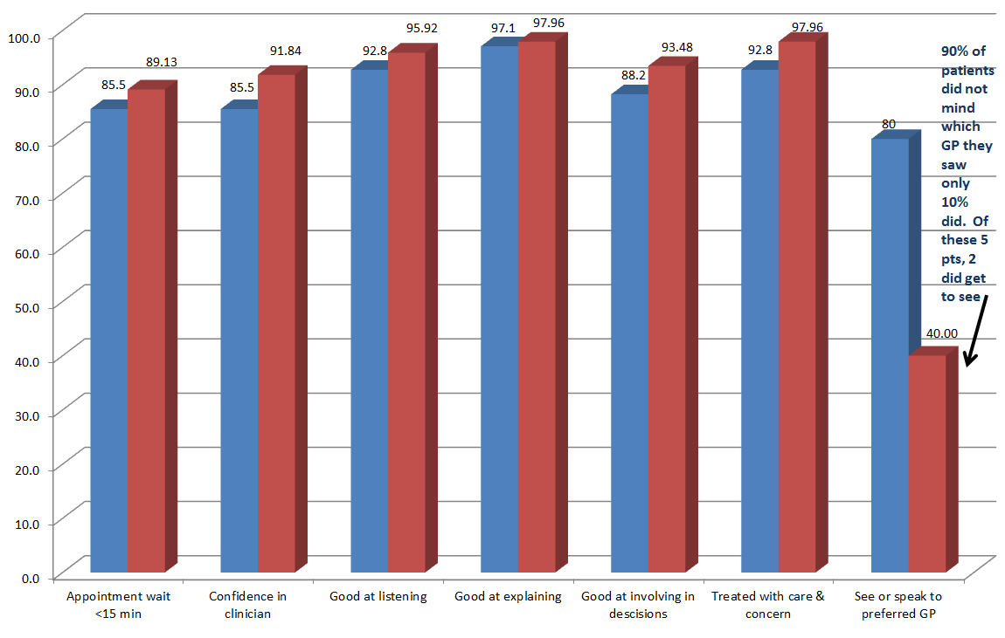
Blue results are 2017, Red results are 2018

These results show that for 6 of the 7 questions we asked, results were between 89% and 98%.
89% of appointments wait less than 15 minutes to be seen
92% have confidence in their clinician
96% found their clinician was good at listening
98% found their clinician was good at explaining
93% felt they were involved in their decisions
98% of patients felt they were treated with care and concern
We are always striving to improve our service…
What else have we been doing?
What have we been doing recently to improve our service?
It is easy not to know what is happening behind the scenes,
so here is an explanation of what we have been doing…
At least 12 distinct changes that have improved our service!
- We have completely overhauled our same day appointments system over the last 18 months to improve access.
- We have increased that same day access by over 50%.
- Everyone knows recruiting a GP is very difficult. We are pleased to have recruited a GP, but we would like more, and are constantly searching for them. We have been very pleased to have recruited some wonderful nurses and much of that increase in same day access has been achieved by employing more nurses, many of whom are prescribing advanced nurse practitioners (ANP).
- We have employed a prescribing clinical pharmacist to directly help our patients with prescription problems, avoiding them needing to wait for a GP appointment, and using the clinical pharmacist’s expertise.
- We have employed new secretaries who can speak directly with patients to help them with referral enquiries, again saving patients having to wait for a GP appointment to deal with something that a secretary can safely deal with, then releasing those GP appointments for problems that only a GP can deal with.
- We send most of our clinical results by SMS text, so that patients get their results sooner and don’t have to ring for the results.
- We have changed our telephone call back system, so that our patients are usually offered a clinically appropriate appointment with an Emergency Care Team clinician within hours of the call, rather than having to await a call back “sometime over the next two hours” to be given an appointment.
- Call backs to patients on the Emergency Triage team, when a patient’s problem may be able to be dealt with over the phone, now usually happens within half an hour of the patient’s original call, rather than the historic potential 2 hour delay. Many times I have rung a patient, for them to say variants of “Wow, I’ve only just put the phone down from your receptionist, thank you for returning my call so quickly”.
- We have worked with a paramedic to visit some of our patients, enabling fewer GP and ANP visits, with a consequent increase in GP and ANP appointments.
- We have worked really hard with our patient participation group, a GP now attends all PPG meetings, and we discuss the findings of the meeting at our GP Partners’ meeting.
- The number of PPG members has more than quadrupled!
- We have operated our own transparent patient survey, with the help of our PPG.
- These results show that for 6 of the 7 questions we asked, results were between 89% and 98%. The one that is poor, shows the true risk of statistics, where it shows that only 40% of patients who asked to see a GP saw their preferred one. What it doesn’t say is that 90% of patients did not mind which GP they saw and that the 40% actually only represented 2 patients. We are a practice of over 21,500 patients. Our hardworking staff work tirelessly every day to improve the service we offer, and so when a national survey represents our practice based upon only 111 patient responses, it belittles that daily hard work.
- We offer 200 on the day emergency appointments every single day. That is over a 1000 urgent appointments every week, 50000 urgent appointments every year!!
- We always see a patient who clinically needs to be seen.
- We offer over 2000 appointments a week.
- Then for our whole service to be brought down to that tiny number of responses, it is really upsetting and demoralising for our staff. We work really hard with our staff, who are a great team, to help remind us all what a good quality job we are doing for our patients. It also makes recruitment and retaining staff yet harder when they feel unappreciated by the patients they want to serve.
- The results of our survey completely contrast with those of the National patient survey, despite the questions being deliberately taken to match those asked by the National survey, reflecting high satisfaction with our service, such that they would recommend it to members of their friends and family
This shows that during 2018, 87% of patients were either extremely likely or likely to recommend our practice to their friends or family.
- We therefore struggle to understand the results of the National survey, yet we strive to always improve.
- We think that when patients get appointments, they are happy with the quality of them, but that there are simply not enough, we are continually trying to increase our appointment numbers within the resources that are available to us.
- I think it is really important to hear some of the patient comments from 2018. Here are just the titles of our positive NHS choices
Gobsmacked by the high quality of today's service
Excellent service
Excellent Friendly Service
Excellent service when you need it most
Very much improved
Very satisfied
Never had a problem
Much improved!
Good call back service
Amazing as always...
Can’t fault this morning’s service

We have some of the best GPs in the country !
….beating every national benchmark!

