HEALTH & WELLBEING at THE CAFÉ
PLEASE JOIN US
for
A FREE, informative presentation on
‘Living with Food Allergies’
by Professor Richard J Powell,
Consultant @ BMI Three Shires,
Thursday October 17th 1.15pm – 3 pm
(45 minute talk at 1.30pm followed by help & advice)

Pendle Road Café
Duston Community Centre
NN5 6DT
Refreshments available
Please call us to book your FREE place
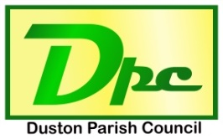
Duston Parish Council working in partnership with St Luke’s PPG

T: 01604 583626 E: bcdm@duston-pc.gov.uk
www.duston-pc.gov.uk

